**Instructions for running this program:**

1. Save these files in the zip folder to your machine:
   1. client.py
   2. server.py
2. Open two command line windows.
   1. In window 1, run server.py using python 3 (be sure to run this first).
   2. In window 2, run client.py using python 3.
3. Start chatting, where the client enters the first message.
4. Either the client or the server enters “/q” to end the chat session.

**Results from of a chat between the client and the server where the client quits first:**

Client chat window:

Server chat window:

**Results from of a chat between the client and the server where the server quits first:**

Client chat window:

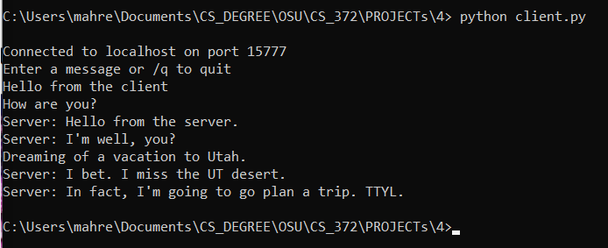

Server chat window:

